Entrance guarding with SpeedDome and panorama camera
Speed domes have the ability to zoom in for superb detail, but can only focus on a small area at one time. Panorama cameras, on the other hand, cover the entire area but can't see the detail as speed domes do. While patrol function improve the coverage of speed domes, it's still no match for panorama. With Genius Vision NVR, the strength of both can be easily combined.

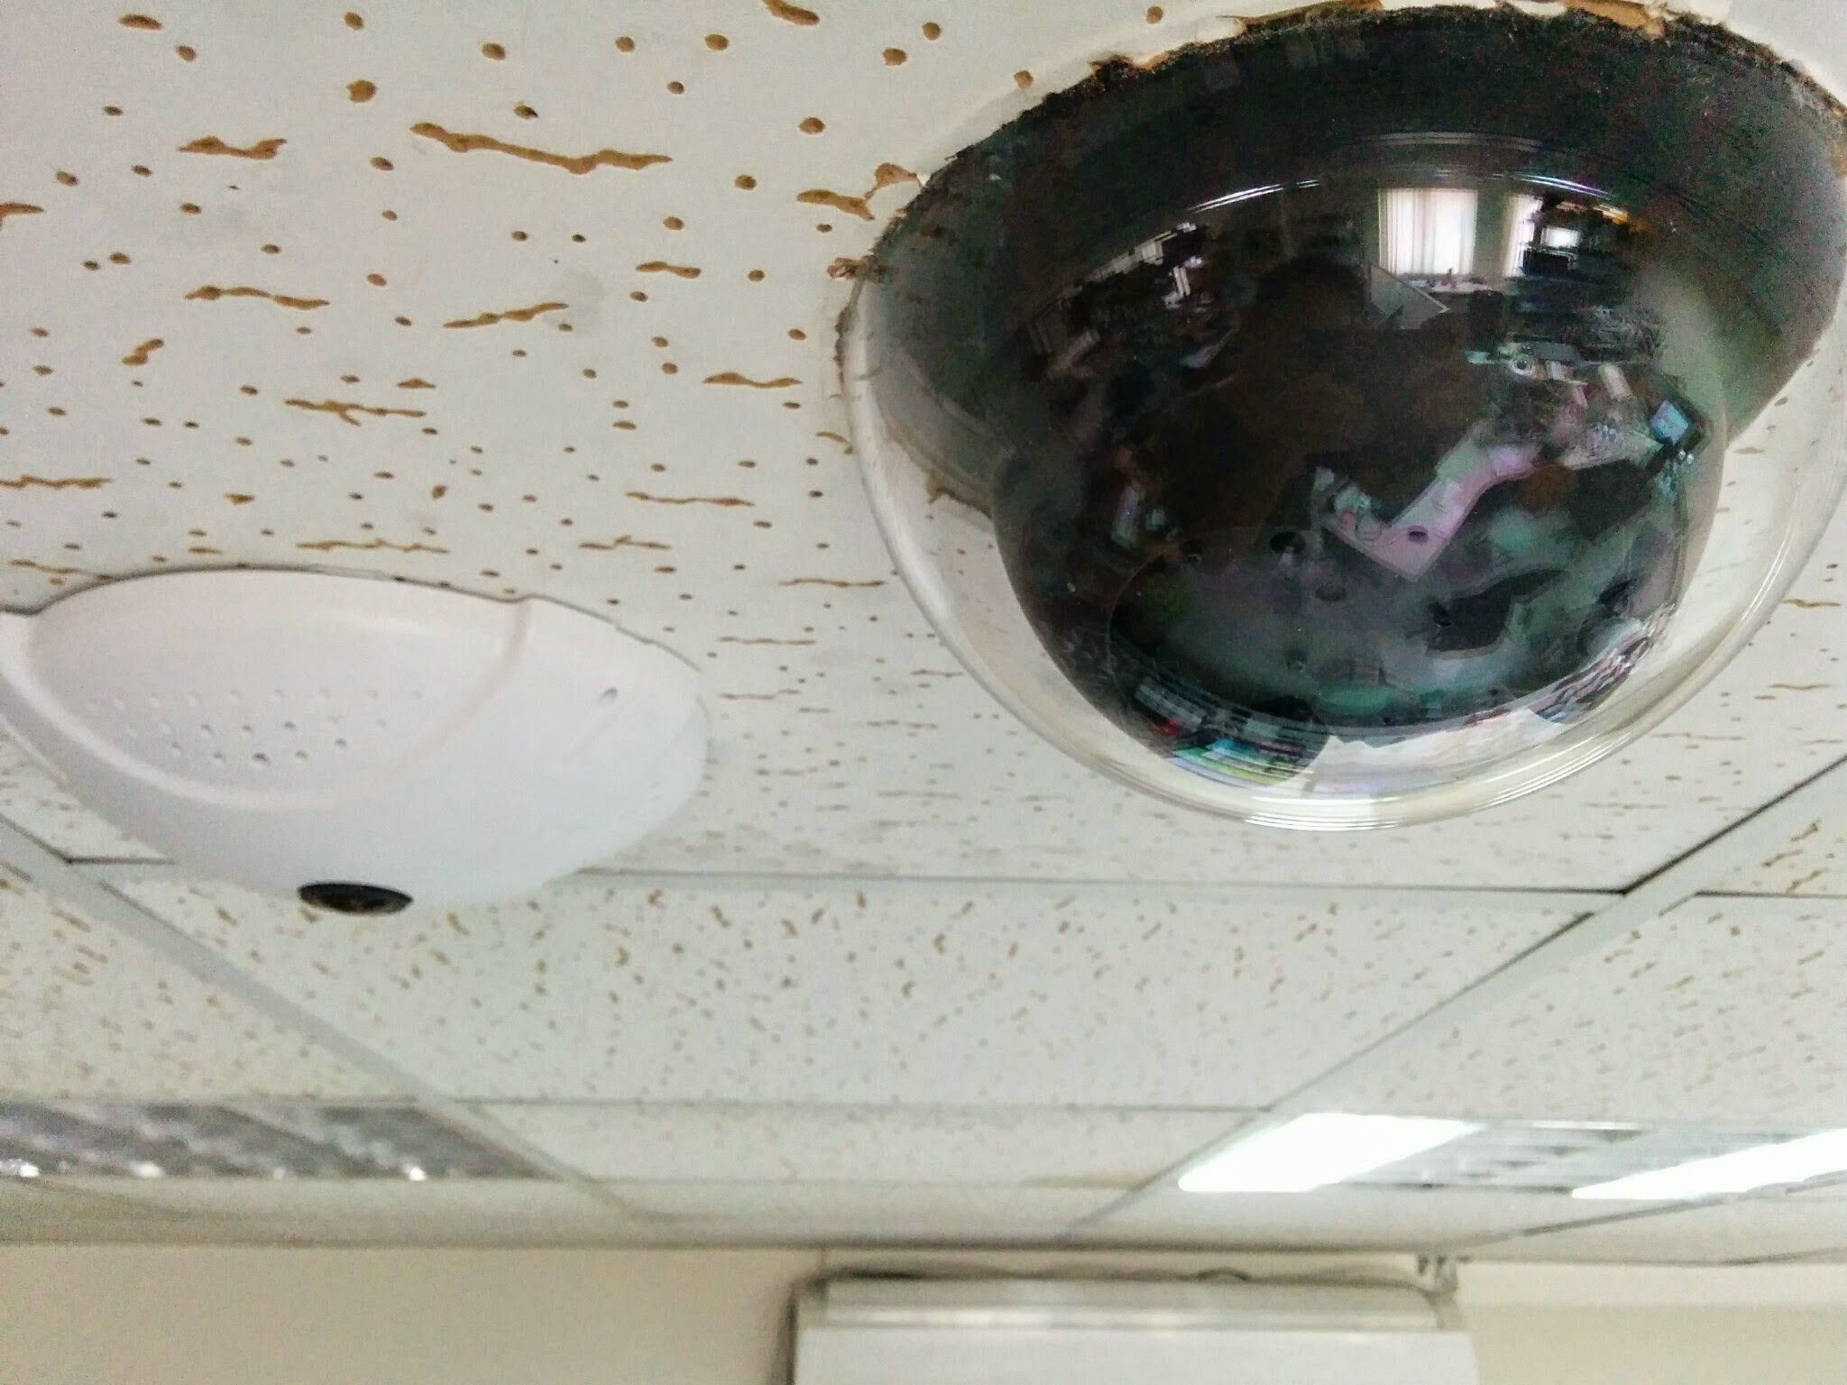

With the flexible and comprehensive Trigger Policy and Motion Detection provided by Genius Vision NVR, a panorama camera can be used to guide a speed dome, by calling preset points upon motion.
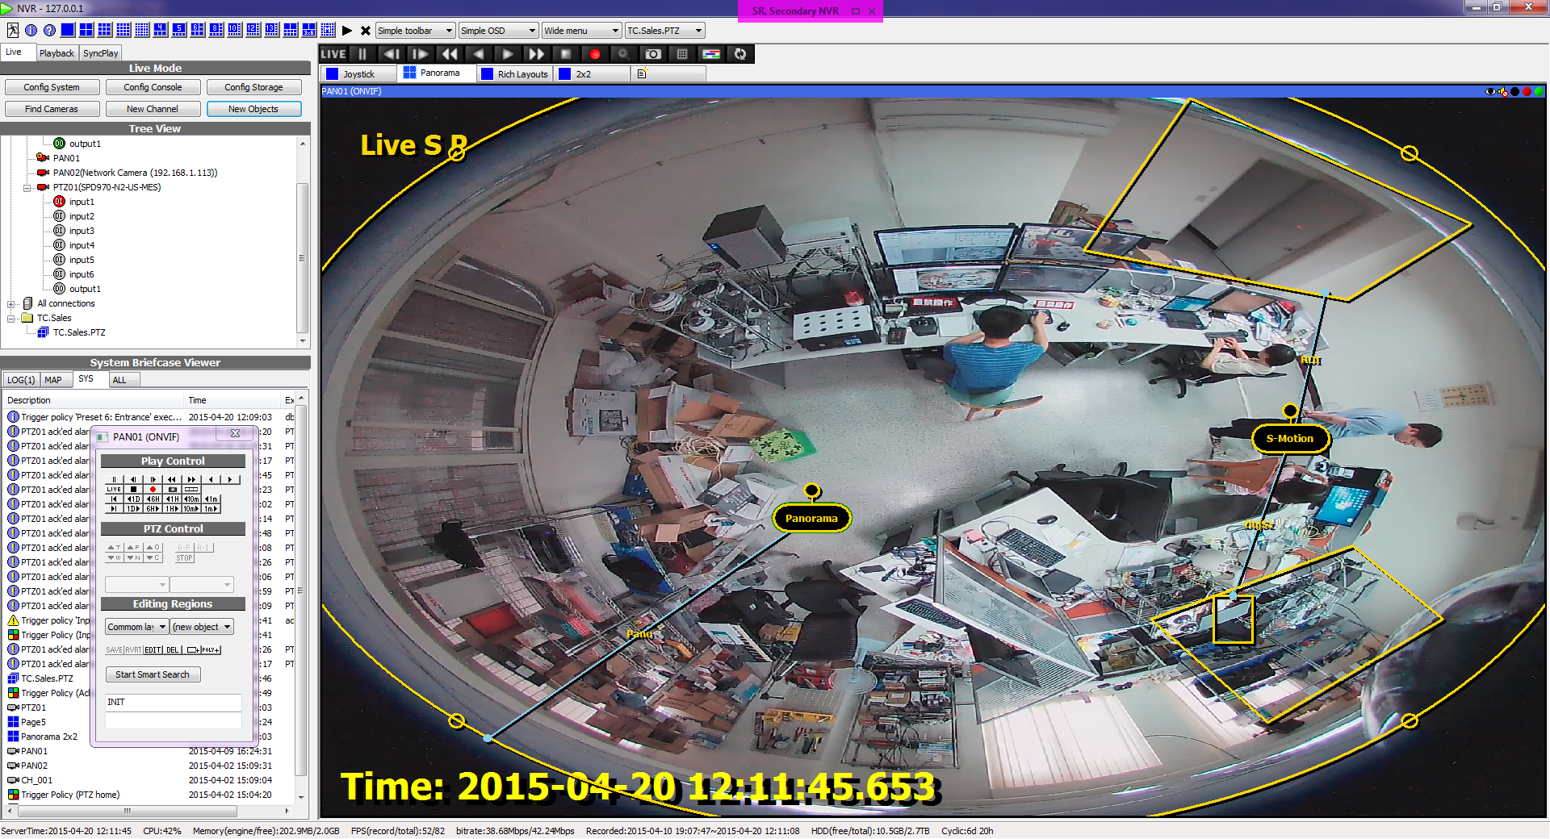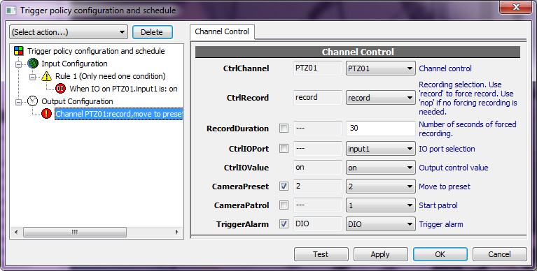

Considering that there is an office with only one entrance, one speed dome and one panorama camera are installed at the center. The speed dome patrols when there's no unusual activity, and focus on the entrance immediately when someone walks through the entrance.

[video]
https://youtu.be/pkAVaS32iAc

The panorama camera can be replaced with multiple box cameras with similar setup. Box cameras are less expensive. But installation and maintenance are more complicated as the number of camera grows.

Equipments
Pixord ND736E | 5 megapixels  360°/180° Fish-eye  PoE
Messoa SPD970 | 3 megapixels  H.264  18x Optical Zoom (focal length 4.7~84.6mm)

Reference
Motion Detection
Using Panoramic Camera
Trigger Policy

