Ordering Info: NH265-16
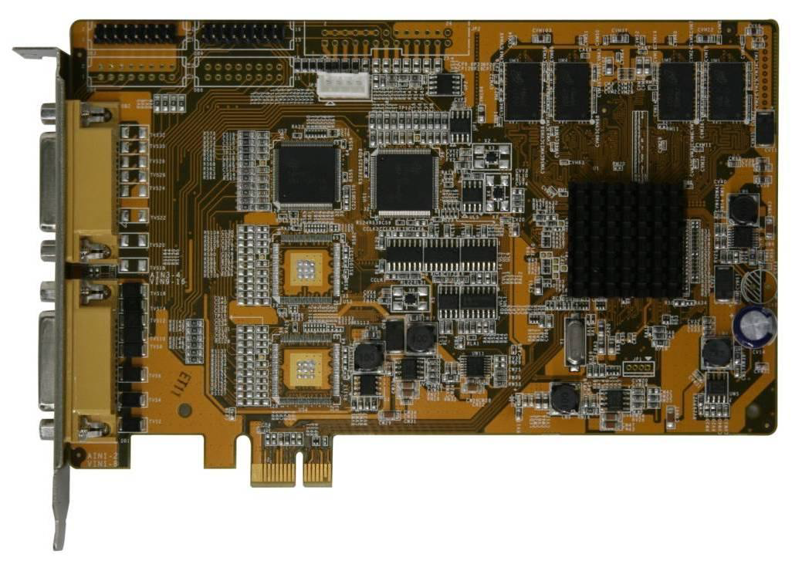

NH265-16 Technical Specification
PCI-E | PCI-Ex1 2.0 compliant
Dimensions(mm) | 175 ×102
Power consumption | < 9.4w
Video compression | H.264, NTSC/PAL auto-detect
Number of video input | 16
Video input connector | BNC(1.0Vp 1.0Vp，75Ω)
Preview resolution | D1
Recording resolution | CIF/D1
Encoding FPS per channel | 1~25 PAL, 1~30 NTSC
Encoding FPS per card | When D1 16-channels, max 300 FPS per card
Audio compression | MPEG audio
Number of audio input | 16
Audio input connector | BNC(2.0Vp 2.0Vp 2.0Vp-p，1000Ω ，audio volume control range 83DB)
Audio sampling rate | 16kHZ

Features
- PCI-E port allows more bandwidth for fluent data transfer.
- Hardware compression allows low CPU utilization.
- Excellent live preview and recorded video quality.
- Reliable and stable suitable for long time operation.
- High performance with low power consumption.
- Real-time video and audio synchronized compression without dropping frames.
- Configurable encoding picture type (I frame, P frame, etc)
- Configurable picture quality and data bit-rate.
- Supports hardware motion detection.
- Support OSD with all Unicode characters support (including traditional & simplified Chinese)
- Support adjustment of image brightness, hue, saturation, and contrast.

