Overview of NVR System Data
Procedure for Backup/Restore/Transfer License Information
Concepts of Online License Mechanism
Transferrable Online License
Backup/Restore Offline License
Backup/Restore License
Overview
Export (Backup)
Import (Restore)
Procedure for Lost Administrator’s Password
I changed some configuration now NVR does not start. What can I do?

Overview of NVR System Data
All system data that will be used to properly maintain a Genius Vision NVR installation are:

Data block | Physical location | Description
Software installation of a particular version | C:\Program Files | The main software function
License information | System Registry | License information that is generated for a particular hardware/software environment. This information in only valid for one computer.
System database | C:\GeniusVision_SystemDb.dbx | System configuration, including users, passwords, camera configuration, recording configuration, and recent alarms etc.
Event database | C:\GeniusVision_EventDb.dbx | Records of type of video events with start/end time.
Archiver database | C:\GeniusVision_ArchiverDb.dbx | Index data of recorded footage. This file is automatically rebuilt from recorded footage if destroyed or missing.
Recorded footage | In the “gvrec” subdirectory of every configured recording drive. | The physical storage of recorded video.

Procedure for Backup/Restore/Transfer License Information

Concepts of Online License Mechanism
Online license authorization offers software publisher a more flexible way to sell license and to eliminate additional logistic cost. In NVR system, it even gives the flexibility to license software in per-single-channel basis. Therefore it's more cost-effective to the customers.

In our system, there are two types of license:
- Online license: This type of license requires periodic Internet check of license validity. It allows users to transfer license from one computer to another, as long as the maximum concurrent license does not exceed the purchased ones. In most scenario, this offers greatest flexibility, highest cost efficiency, and minimum risk.
- Offline license: This type of license does not require Internet when normal operation. However it needs to be "bound" to a specific computer. The operation to bind a license to a computer is called "commit". If you committed a license to a computer, it became fused to that specific computer state (including its system and the underlying hardware). If you change the underlying system or hardware, you risk losing the license.

It is generally recommended unless situation is required, one should avoid using offline license and choose the online one. Even if offline scenario is required, one should start from using online license. After a period of stable running, one can always convert online license directly to offline ones through the process of committing.

More details please refer to User’s Manual.

Transferrable Online License
From the “concepts” sections above, we learn that if you keep the license as “online license”, then you don’t need to worry about online transferring. As long as you are connected to the Internet, the license can always be transferred to another computer. You just need to make sure that you don’t use them at the same time, otherwise license constraint will be broken.

Backup/Restore Offline License
If you committed your license to a specific hardware/software environment, the license became non-transferrable offline license. Nevertheless there comes time that you may need to reinstall your system for some reasons. In this case, you need to backup and restore the license. Please note you can only restore to the original computer you performed backup. The license you backup won’t work on other computers.

For the backup/restore operation please go to next section.

Backup/Restore License
Note: This function is available since version 769.

Overview
Sometimes if the whole system is overwritten for some reason (reinstallation of the OS) or accidentally purges the entire software installation, the license information could be gone permanently. To prevent this from happening, you need to backup the license and restore it when needed.

Note: that you can only restore license to the same system (OS+computer hardware). Restoring to different system will render the license useless.

To use license import/export, select ‘Export/Import installed licenses’ and click Next..
.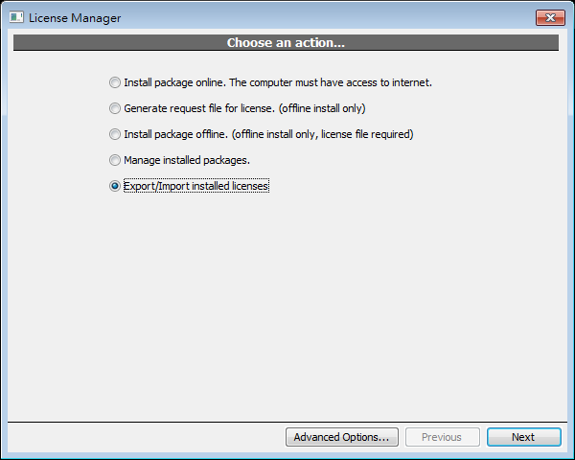
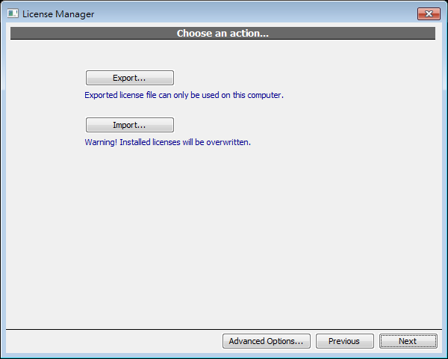

Export (Backup)
Input a filename and click Save..
.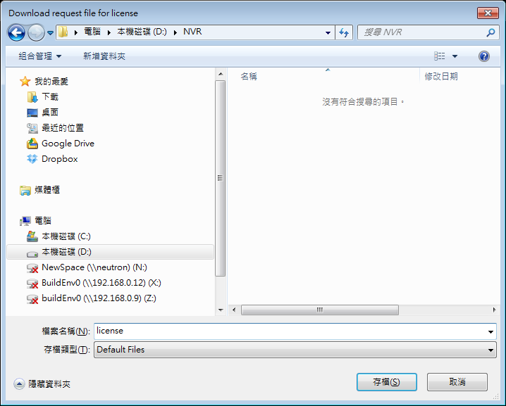
A message is displayed if license is exported successfully.
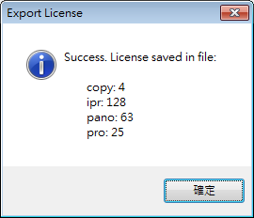
And Export button will be replaced with ‘Browse In Folder’. Click to browse the file in Windows file manager.
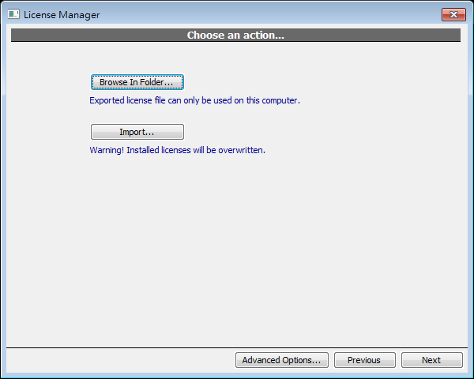

Import (Restore)
Select exported file and click Open.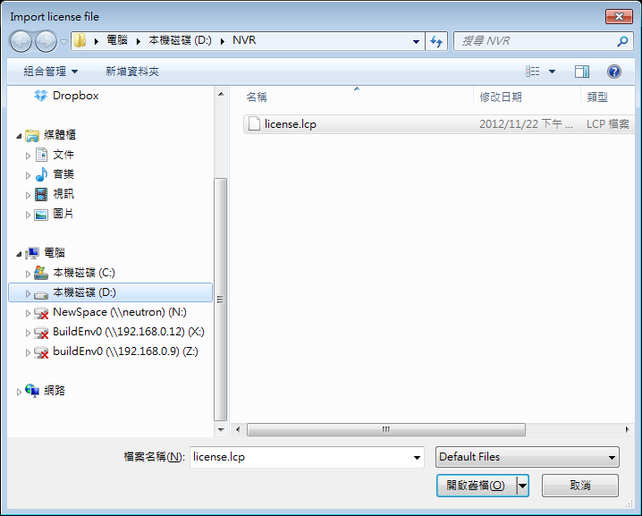
If there’s license already installed, a confirmation dialog is displayed. Click yes to proceed importing
.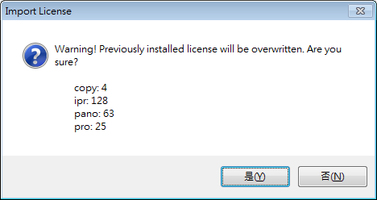
License manager has to be restarted to see imported license
.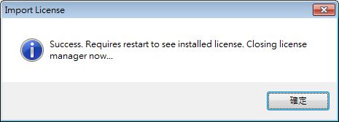

Procedure for Lost Administrator’s Password
Warning: Please make sure you have administrative ownership to the system you are referring to. Doing instructions below will have destructive effect on your NVR system configuration:

To reset system password, you have to reset system config by deleting C:\GeniusVision_SystemDb.dbx.

You need to deactivate engine before doing so. After you do this, all system configuration will be reset (deleted), including your password (and camera settings etc).

I changed some configuration now NVR does not start. What can I do?
Warning: Please make sure you have administrative ownership to the system you are referring to. Doing instructions below will have destructive effect on your NVR system configuration:

Sometimes incorrect or inappropriate configuration could render the system unable to start. There can also be rare possibilities that physical disk error occured exactly at this critical system file that can render system unable to start.

When encountering this kind of problem, one can choose to use Safe Mode (please refer to user's manual) or alternatively use the steps described below:

Nearly all system configuration is stored on C:\GeniusVision_SystemDb.dbx. So by deleting this file, you give the system a chance to restart by giving a whole new system state. Consequently, all previous system configuration will be lost, and you need to setup everything from scratch.

A more prudent way is that you can choose to backup this file before deleting, in case something else is prevent the system from starting.

