How to start NVR Enterprise (x64) trial?
What are the differences between 32-bit editions and 64-bit editions
Memory limit
64-bit system limit extension
64-bit removed legacy camera drivers
64-bit removed features
Does the Enterprise Edition share the same feature as Commercial Edition?
Does the Enterprise Edition require a different kind of license?
New License Type Explained
Does Enterprise Edition runs on 32-bit Windows?
Can I upgrade a 32-bit NVR server to Enterprise Edition?
Can I downgrade an Enterprise Edition server to 32-bit Commercial Edition NVR?

How to start NVR Enterprise (x64) trial?
As explained here, NVR Enterprise Edition requires a new license type, in addition to existing Commercial license (Professional/Intelligent/Panoramic).

To start Enterprise trial, you will use the following trial code upon software installation:

Enterprise Edition trial key: DVL9Q-QGFCG-AW51T

Upon installation, you will be prompted for such code, illustrated by the following screenshot:
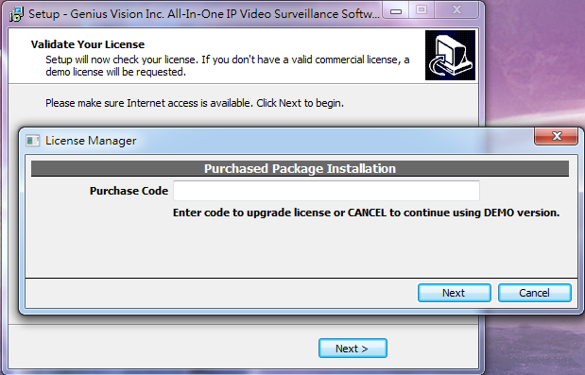

In the future, if you need to upgrade trial to formal installation, simply reinstall the software and re-enter the formal code again.

What are the differences between 32-bit editions and 64-bit editions

Memory limit
Due to the OS nature, 32-bit application are limited to 4GB memory, while 64-bit applications does not have such limit.

64-bit system limit extension
Due to the fact that x64-based system comes with more available system resource (if configured properly), x64 build of NVR software has extended several system limits and/or default values, as illustrated below:
 | 32 bit | 64 bit
Maximum allowed TCPConnections (Image 1) | 1,000 | 2,000
Default TCPConnections | 150 | 1,000
Storage MaxSize_GB per directory (Image 2) | 20,000 | 80,000
Default MaxSize_GB per directory | 1,000 | 1,000
Maximum number of monitors supported (Image 3) | 6 | 8
Maximum number of matrix view | 256 (16x16) | 400 (20x20)

64-bit removed legacy camera drivers
64-bit drivers needs 64-bit camera SDK/drivers to work. Some vendors do not provide 64-bit SDK/driver therefore aren't supported in 64-bit editions. They are:
- ACTi
- ArecontVision
- EtroVision
- VIVOTEK

64-bit removed features
Some features require components that does not have 64-bit counterpart, therefore is removed from 64-bit editions. They are:
- 3GStreaming (You should use the newly developed Mobile APP instead)

Does the Enterprise Edition share the same feature as Commercial Edition?
Except for the known difference, Enterprise Edition shares almost all features with Commercial Edition.

However, as the 64-bit Introduction suggested, 64-bit applications are ported from 32-bit and they are of entirely different application. They might be minor behavior differences that are yet to be tested & verified.

Does the Enterprise Edition require a different kind of license?
Enterprise Edition are compatible with Commercial Edition license (Professional/Intelligent/Panoramic), but it requires an additional per-server license, called Enterprise License (codenamed copye).

New License Type Explained
- New license type: copye is a new license type that will be available for purchase. License fee will be defined somewhere else.
- License applicability & installation: For Enterprise Edition, one server (PC) requires exactly one unit of copye to function correctly, otherwise "Protection lock error" will be encountered and the software won't start. This special license code will be asked at installation time (see Image 4).
- Trial & production mode: In demo mode, copye comes with 8-channel of trial license with IVS and panorama features enabled to facilitate trial purpose. In product mode (non-trial), copye does not bring additional per-camera license. Therefore additional per camera license (such as pro, ipr, pano) must be purchased and installed separately.

Does Enterprise Edition runs on 32-bit Windows?
No.

You need a 64-bit Windows operating system in order to run Enterprise Edition.

Can I upgrade a 32-bit NVR server to Enterprise Edition?
Yes.

You can do so just by installing 64-bit Enterprise over an existing 32-bit NVR server (and of course you need a 64-bit Windows operating system).

All configuration will be kept, but you'll need an additional copye license, as stated here.

Can I downgrade an Enterprise Edition server to 32-bit Commercial Edition NVR?
Yes.

You can do so just by installing 32-bit NVR over an existing 64-bit Enterprise NVR server.

All configuration will be kept.

